**MAJOR PROJECT REPORT**

COURSE CODE: CSE6D

(VIRTUAL VOICE ASSISTANT)

Program & Section : Diploma CSE JK802

Submitted by:

Kunal Kumar, Vishal Prajapati, Dheeraj Kumar , Aniket Bawa , Sarfaraj Alam Registration No:- 11808335,11905783,1180756,11807056,11908297

**Under the Guidance of**

Sweety Sehgal

Amandeep Kaur Sandhu

School of polytechnic

Departement of Computer Science

Lovely Professional University , Phagwara

DECLARATION

We do hereby declare that the report entitled “Voice-Assistant” is an authentic record of our work carried out as requirement of Major project for the award of degree of: diploma CSE from Lovely Professional University, Phagwara, under the guidance of Miss Sweety Sehgal Miss, Amandeep Kaur Sandhu.

Name of student: Kunal Kumar

Reg no: 11808335

Name of student: Vishal Prajapati

Reg no:11905783

Name of student: Sarfraz

Reg no: 11908297

Name of student: Dheeraj Kumar

Reg no: 11807027

Name of student: Ankit Bawa

Reg no: 1180756

Date :

This is to certify that the above statement made by the student is correct to the best of my Knowledge and belief.

**(Name,U.ID and Designation)**

ACKNOWLEDGEMENT

We would like to express our special thanks of gratitude to our mentor **Miss Sweety Sehgal, Miss Amandeep Kaur Sandhu.** who gave us the golden opportunity to do this wonderful project on the basic of Minor Project , which also helped us in doing a lot of Research and we come to know about so many new things we are really thankful to her.

Secondly , we would like to thank our parent who inspect of being far away from us continuously encourage us to do our best in every condition as a result of which we were able to work in a pandemic enjoyment .without their moral support , it was very difficult to complete this project.

Finally , I would also like to thanks my whole team who helped us a lot in finalizing this project within the limited time frame.

|  |
| --- |
| INDEX |
| 1. Profile of a Problem |
| 1. Literature Survey |
| 1. Problem Analysis |
| 1. Software Requirement Analysis |
| 1. Design |
| 1. Code Design Implementaion |
| 1. Bibliography |

Problem Definition

We are all well aware about Cortana, Siri, Google Assistant and many other virtual assistants which are designed to aid the tasks of users in Windows, Android and iOS platforms. But to our surprise, there’s no such virtual assistant available for the paradise of Developers i.e. Linux platform.

**Purpose:-**

This Software aims at developing a personal assistant for Linux-based systems. The main purpose of the software is to perform the tasks of the user at certain commands, provided in either of the ways, speech or text. It will ease most of the work of the user as a complete task can be done on a single command. Jarvis draws its inspiration from Virtual assistants like Cortana for Windows and Siri for iOS. Users can interact with the assistant either through voice commands or keyboard input.

PRODUCT DESCRIPTION

As a personal assistant, Jarvis assists the end-user with day-to-day activities like general human conversation, searching queries in various search engines like Google, Bing or Youtube, searching for videos, retrieving images, live weather conditions, word meanings. The user statements/commands are analysed with the help of machine learning to give an optimal solution.

The Most famous application of iPhone is “SIRI” which helps the end user to communicate end user mobile with voice and it also responds to the voice commands of the user. Same kind of application is also developed by the Google that is “Google Voice Search” which is used for in Android Phones. But this Application mostly works with Internet Connections. But our Proposed System has capability to work with and without Internet Connectivity.

Literature Survey

Speech recognition has a long history with several waves of major innovations. Speech recognition for dictation, search, and voice commands has become a standard feature on smartphones and wearable devices. Design of a compact large vocabulary speech recognition system that can run efficiently on mobile devices, accurately and with low latency.This is achieved by using a CTC based LSTM acoustic model which predicts context independent phones and is compressed to a tenth of its original size using a combination of SVD-based compression and quantization. Quantized deep neural networks (DNNs) and on-the-fly language model rescoring to achieve real-time performance on modern smartphones.

As more data becomes available for a given speech recognition task, the natural way to improve recognition accuracy is to train larger acoustic models. There are a nonparametric empirical model that exploits abundant training data to directly learn pronunciation variation. Interpolating the empirical model with a parametric model yields the best performance, with a relative improvement of 5.2% in WER over the baseline. There are a number of ways in which this work could be extended. First, closer integration with acoustic model training is likely to yield sharper distributions and a tighter fit to the data. Second, estimating wordpronunciation co-occurrence counts in semi-supervised fashion (e.g. through word recognition instead of forced alignment) would broaden its applicability to a wide range of speech genres and tasks.

**Methodology**

1. Speech recognition The proposed system used the google API to convert input speech into text. The speech is given as an input to google cloud for processing, As an output, the system then receives the resulting text. 2. Backend work At backend the python gets the output from speech recognition and after that it identifies whether the command is a system command or a browser command. The output is send back to python backend to give desired output to user. 3. Text to speech Text to speech, or TTS, is a new wave technique of for transforming voice commands into readable text. Not to mix it up with VR Systems that instead, generate speech by joining strings gathered in an exhaustive DB of preinstalled text and have been developed for different goals which form full-fledged sentences, clauses or meaningful phrases through a dialect's graphemes and phonemes. Such systems have their limits as they can only determine text on the basis of pre-determined text in their databases TTS systems, on the other hand, are practically to "read" strings of characters and dole out resulting sentences, clauses and phrases. ii) Proposed Architect

FUTURE SCOPE

The future of voice assistants can be parameterised on an array of dimensions. With respect to compatibility and integration with other devices and systems, there i sill a lot to be achieved, Another dimension would be with respect to the redundant use of wake words at the beginning of each command. The individuality of results also poses a big problems. But for all intents and purposes, the future of these technology is a bright one. With advances in it and in technologies related to it (search processes, for example) Voice assistants can carry out even more complex tasks like booking tickets, etc.

At its core, this technology might have its own trials and tribulations, but it is still a boon for many who might have been kept in the dark with all spheres of technological developments. Apart from this, it is just too beneficial a technology to not go through continuous research and development.

Further, in the long run, Jarvis is planned to feature auto deployment supporting elastic beanstalk, backup files, and all operations which a general Server Administrator does. The functionality would be seamless enough to replace the Server Administrator with Jarvis.

Presently, Jarvis is being developed as an automation tool and virtual assistant. Among the Various roles played by Jarvis are:

1. Search Engine with voice interactions

2. Medical diagnosis with Medicine aid.

3. Reminder and To-Do application.

4. Vocabulary App to show meanings and correct spelling errors.

5. Opening ANY Application

Problem Analysis

We are all well aware about Cortana, Siri, Google Assistant and many other virtual assistants which are designed to aid the tasks of users in Windows, Android and iOS platforms. But to our surprise, there’s no such virtual assistant available for the paradise of Developers i.e. Linux platform.

1. DEALING WITH VARIOUS LANGAUGES

As our team we handling this type of project so we were not aware many type of designing scope which are available in python .

1. VARIOUS DESIGN

Various design ideas and implemeantation problem in the actucal coding.

Software Requirements and Specification

Gigahertz (GHz) or faster processor or System on a Chip (SoC)

RAM: 1 gigabyte (GB) for 32-bit or 2 GB for 64-bit

Hard drive space: 16 GB for 32-bit OS 32 GB for 64- bit OS

Python Version 3.7

All the software and online platform is used for creating and designing the website logo. The website is one of the most critical and important things , basically it is the identification of the platform. And it should be premium is looks and should be attractives to users.

FLOW CHART

RESULT

Accessing youtube videos Videos have remained as a main source of entertainment, one of the most prioritized tasks of virtual assistants. They are equally important for entertainment as well as educational purposes as most teaching and research activities in present times are done through Youtube. This helps in making the learning process more practical and out of the four walls of the classroom. Jarvis implements the feature through a subprocess module which is handled by the main Golang service. This service initiates the subprocess for Node JS which serves the Selenium WebDriver, and scraps the searched YouTube query. In order to access videos from youtube . 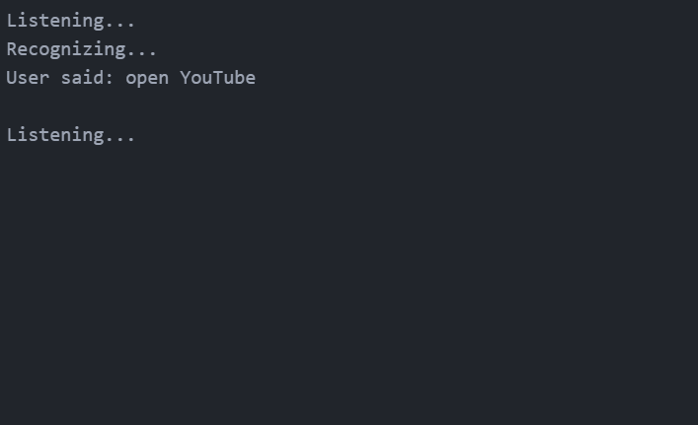

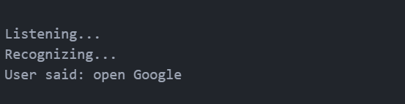

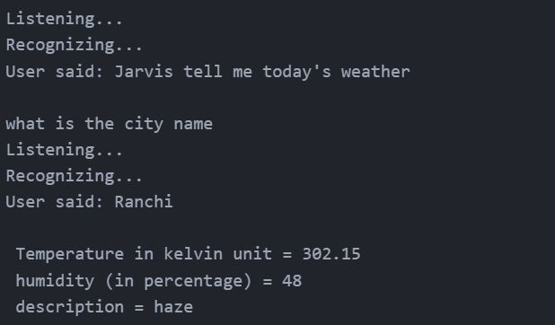

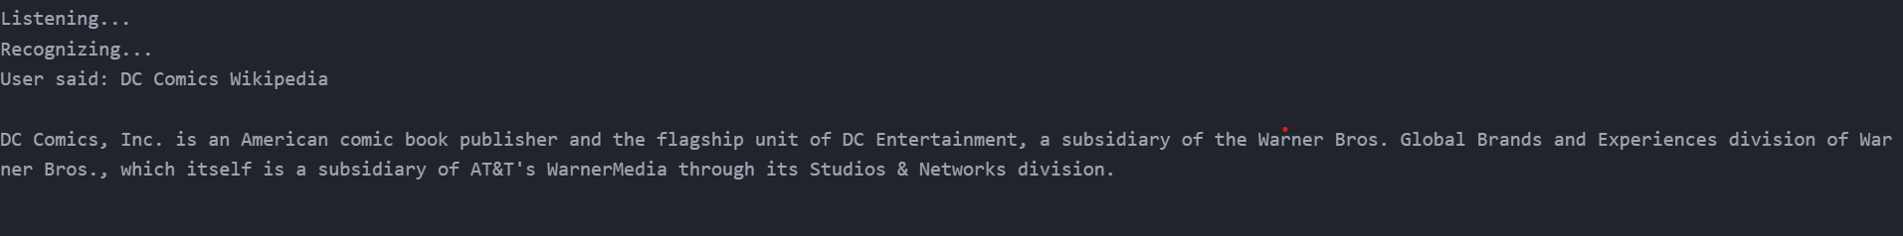

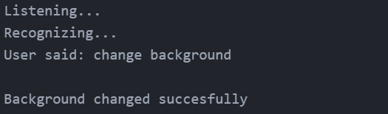

Why to use Voice Assistant ?

1. It fulfils the lack of a virtual assistant in Linux systems.

2. It has an easy to install and use interface.

3. It accepts inputs even through voice or keyboard.

4. It automates tedious tasks like deployment, unit testing through a single command.

5. It gives live weather updates.

6. It gives advice on health.

CONCLUSION

Through this voice assistant, we have automated various services using a single line command. It eases most of the tasks of the user like searching the web, retrieving weather forecast details, vocabulary help and medical related queries. We aim to make this project a complete server assistant and make it smart enough to act as a replacement for a general server administration. The future plans include integrating Jarvis with mobile using React Native to provide a synchronised experience between the two connected devices. Further, in the long run, Voice is planned to feature auto deployment supporting elastic beanstalk, backup files, and all operations which a general Server Administrator does. The functionality would be seamless enough to replace the Server Administrator with Voice..

REFERENCES

1. Sutar Shekhar, Pophali Sameer, Kamad Neha, Deokate Laxman, intelligent voice assistant using Android platform. International Journal of Advance research in computer Science and Management Studies. Volume 3, Issue 3, march 2015

2. Mhamunkar, M. p. v., Bansode, M. k. S., & Naik, L.S. (2013). Android application to get word meaning through voice. International journal of Advance Research in Computer Engineering & Technology (IJARCET). 2(2), pp-572.

3. Apte, T. V., Ghosalkar, S., pandey, S., & Padhra, S. (2014). Android app for blind using speech technology. International Journal of Research in Computer and Communication Technology (IJRCCT), #(3), 391-394.

4. Anwani, R., Santuramani, U., Raina, D., & RL, P. Vmail: voice Based Email Application. International Journal of Computer Science and Information Technologies, Vol. 6(3), 2015

5. Deepak shende, Ria Umahiya, Monika Raghorte, Aishwarya Bhisikar, Anup Bhange.AI based voice assistant using python. JETIR, feburary 2019, vol 6, issue 2.